Courtney Thurston

AP Art History

Mrs. Eckel

U3L2 Art of Ancient Greece I

*The human body is one of the central subjects of ancient Greek art. In a short essay, explain why the human body was such an important subject to the ancient Greeks and how this sculpture reflects Greek ideas and ideals about humanity and the human form. You should identify this work and its stylistic period, and indicate how this sculpture is characteristic of that period.*

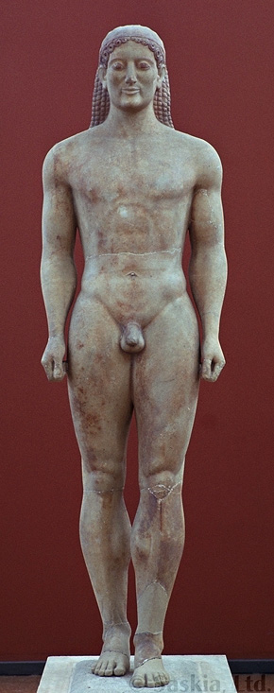

The Greeks developed the idea of the western canon: the relationship between the image and the observed world. Their expressions of humanism displayed the human form and the exercise of human reason in and on the natural world. Thus, the body and reason were the center of reality. The Greeks began to represent figures in their natural form and expression. Figures were realistic and began to resemble normal proportions with the expressions of normal smiles, rounded cheeks and musculature. The work shown is the Kroisos Kouros, circa 530 BCE from the Archaic period in Greek art. It is a face and figure that could exist in the real world; the sculpture represents universal ideals of the human body and human character that all persons could aspire to: human perfection.